What is Long COVID, and How Can HBOT Help Relieve It?
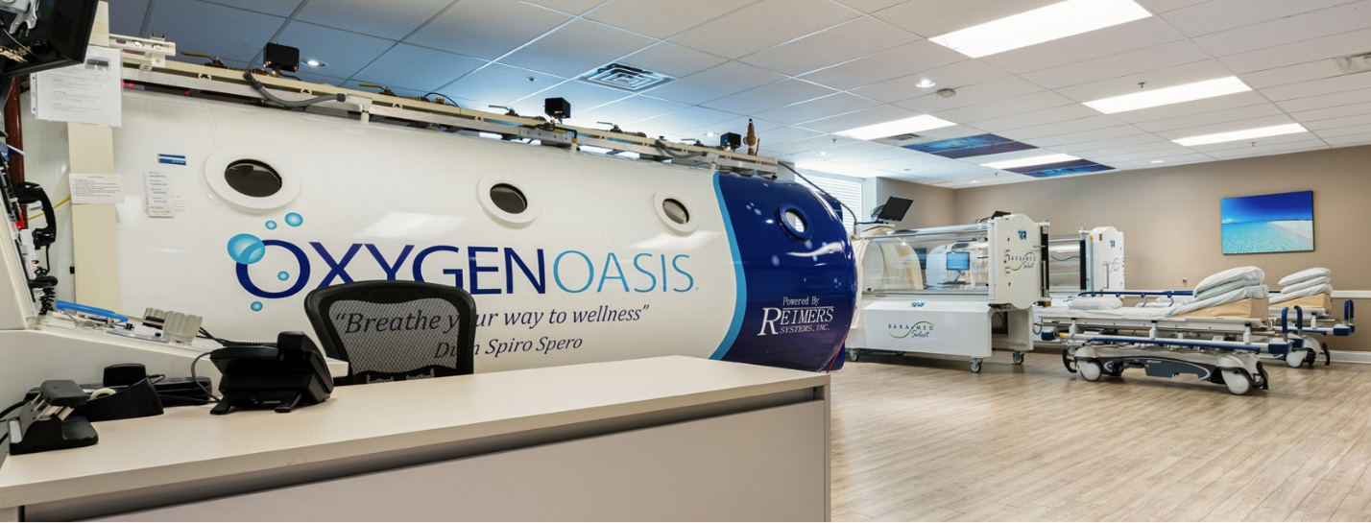
As the pandemic continues to rumble on, various sectors continue to be affected, and the nation's veterans are among them. According to the Department of Veterans Affairs, the number of COVID cases among veterans exceeded 340,000 at the end of last September — and these are just the numbers from official VA-run hospitals, clinics, and medical centers.
Yet although vaccines are causing recovery rates to rise, more than half of COVID survivors feel the effects of the virus long after it leaves their bodies. Here, hyperbaric oxygen therapy (HBOT) can step in to help veterans regain full health. Here's what we currently know about HBOT treatments for long COVID, in particular.

What is long COVID?
Long COVID syndrome (LCOV) occurs when a COVID survivor continues to experience symptoms of the disease for more than 12 weeks, and these symptoms can't be traced to another cause. According to health resource SymptomFind, these symptoms include fatigue, brain fog, dizziness and headaches, loss of taste or smell, difficulty breathing, and fever. In women, LCOV may even manifest in an abrupt stop to the menstrual cycle.
Currently, scientists have a few theories as to why this happens. One postulates that COVID is an autoimmune disease that attacks not just the virus, but the body's own tissues. Another explanation theorizes that dormant fragments of the virus are somehow reactivated, causing COVID symptoms to reappear.
Studies thus far also indicate that long COVID is not correlated to case severity. Instead, it occurs in healthier patients that did not receive medical care during their bout with the original COVID infection. On the whole, researchers from Penn State predict that more than half of the world's COVID survivors will be "long haulers."

How can HBOT help?
A quick refresher on HBOT: once a patient is in the chamber, they breathe in 100% pure oxygen in an environment with an atmospheric pressure of 3 atmosphere absolute (ATA). In comparison, we normally breathe in a mere 21% of oxygen in an environment with only 1 ATA. For treating long COVID, however, pressure is kept anywhere between 2.0 to 2.5 ATA. Increasing the saturation of oxygen in the body can facilitate increased capillary growth and white blood cell activity, the development of new tissue, and countless other physiological benefits.
Though HBOT will still bring these benefits to long haulers, it will help them by reversing neurological hypoxia and reducing neuroinflammation. According to science magazine Scientific American, this is because even mild COVID cases can result in reduced brain volume and difficulty in processing information.

What this means for afflicted vets
For over a decade now, the TreatNOW Coalition has advocated HBOT as a healing treatment for veterans who have suffered brain injuries and PTSD in service. The evidence of HBOT's benefits for LCOV only continues to grow, and this further proves that now is the time for Congress to take definitive action on veteran healthcare.
Indeed, TreatNOW's mission is made increasingly important today, in a time where COVID-19 is one of the hazards of active duty. By successfully pushing for state-funded HBOT, veterans can be given the pain-free, fulfilled, and healthy lives that they rightfully deserve.

